Lab 9

# Programs to illustrate the following classes

# Mouse Adapter

## Code

import java.awt.*;

import java.awt.event.*;

public class Lab9_Mouse {

    public class mouseAdapterClass extends MouseAdapter {

        Frame f;

        public mouseAdapterClass() {

            f = new Frame("Mouse Adapter");

            f.setSize(500, 500);

            f.setLayout(null);

            f.setVisible(true);

            f.addMouseListener(this);

            f.addWindowListener(new WindowAdapter() {

                public void windowClosing(WindowEvent windowEvent) {

                   System.exit(0);

                }

            });

        }

        public void mouseClicked (MouseEvent e) {

            Graphics g = f.getGraphics();

            Color randomColor = new Color((int)(Math.random() * 0x1000000));

            g.setColor (randomColor);

            g.fillRect (e.getX(), e.getY(), 30, 30);

        }

    }

    public static void main(String[] args) {

        Lab9_Mouse L = new Lab9_Mouse();

        mouseAdapterClass M = L.new mouseAdapterClass();

        M.getClass();

        System.out.println("Mouse Adapter Class Executed!");

    }

}

## Output

1. Console output:

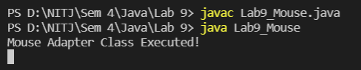

1. The new frame created:

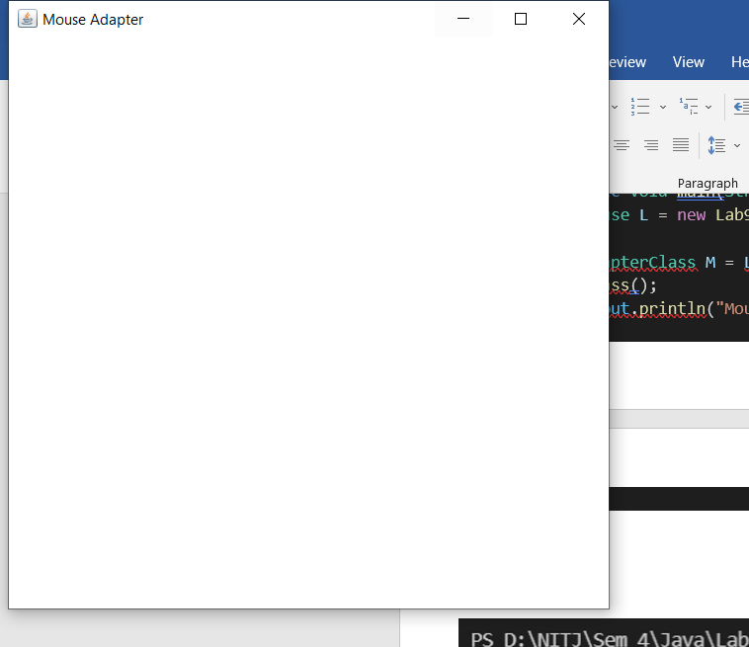

1. The frame in full screen after clicking a few spots
2. The frame can be closed by clicking the cross on top right, or by typing ctrl+c in the console

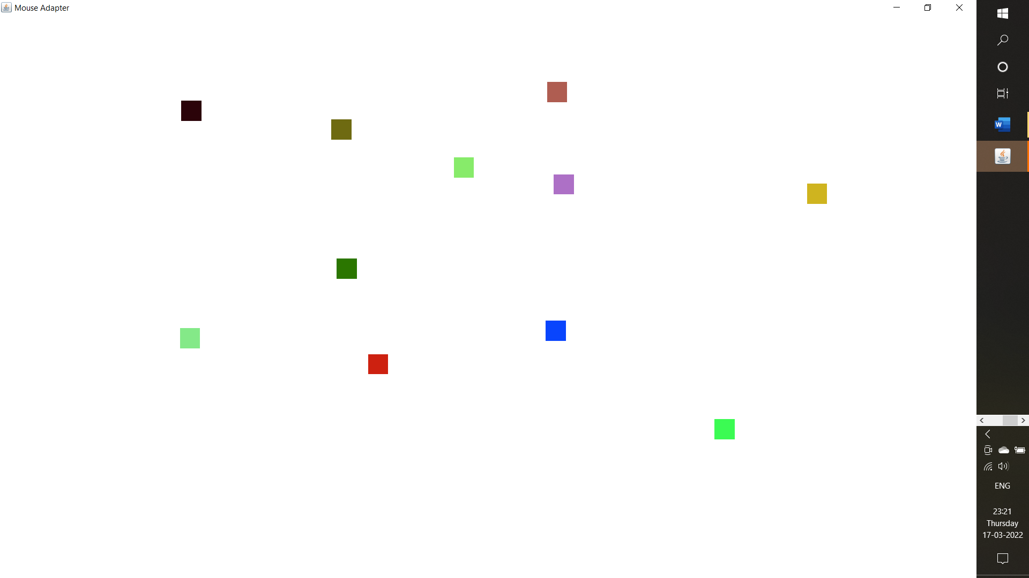

# Key Adapter

## Code

import java.awt.*;

import java.awt.event.*;

public class Lab9_Key {

    public class keyAdapterClass extends KeyAdapter {

        Frame f;

        TextField textArea;

        Label label;

        public keyAdapterClass() {

            f = new Frame("Key Adapter");

            f.addWindowListener(new WindowAdapter() {

                public void windowClosing(WindowEvent windowEvent) {

                    System.exit(0);

                }

            });

            textArea = new TextField();

            textArea.setBounds(50, 50, 400, 200);

            textArea.setBackground(Color.LIGHT_GRAY);

            textArea.addKeyListener(this);

            label = new Label();

            label.setBounds(0, 100, 500, 500);

            label.setAlignment(Label.CENTER);

            f.setSize(500, 500);

            f.setLayout(null);

            f.add(textArea);

            f.add(label);

            f.setVisible(true);

        }

        public void keyPressed(KeyEvent e) {

            if(e.getKeyCode() == KeyEvent.VK_ENTER) {

                label.setText("Entered text: " + textArea.getText());

            }

        }

    }

    public static void main(String[] args) {

        Lab9_Key L = new Lab9_Key();

        keyAdapterClass K = L.new keyAdapterClass();

        K.getClass();

        System.out.println("Key Adapter Class Executed!");

    }

}

## Output

1. Console Output:

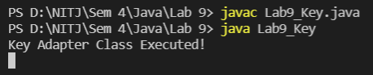

1. The new frame created:

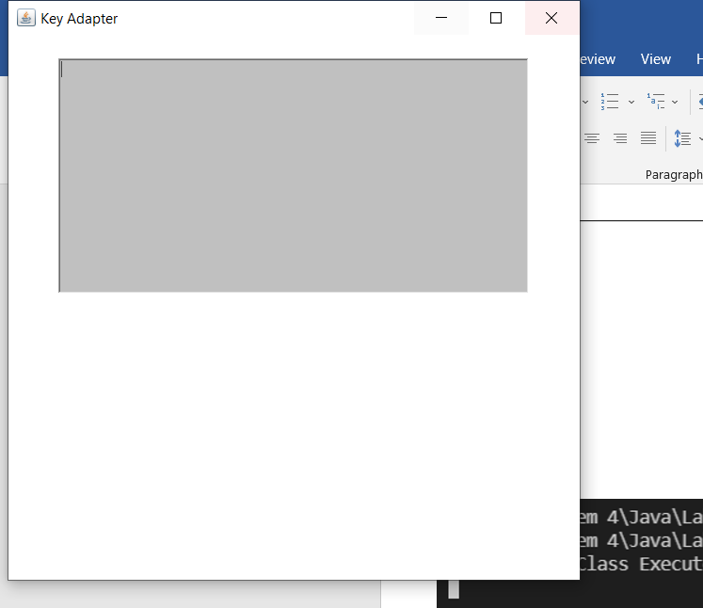

1. The frame in full screen with some letters typed in
2. After typing ABCDEF, enter was clicked to get the output

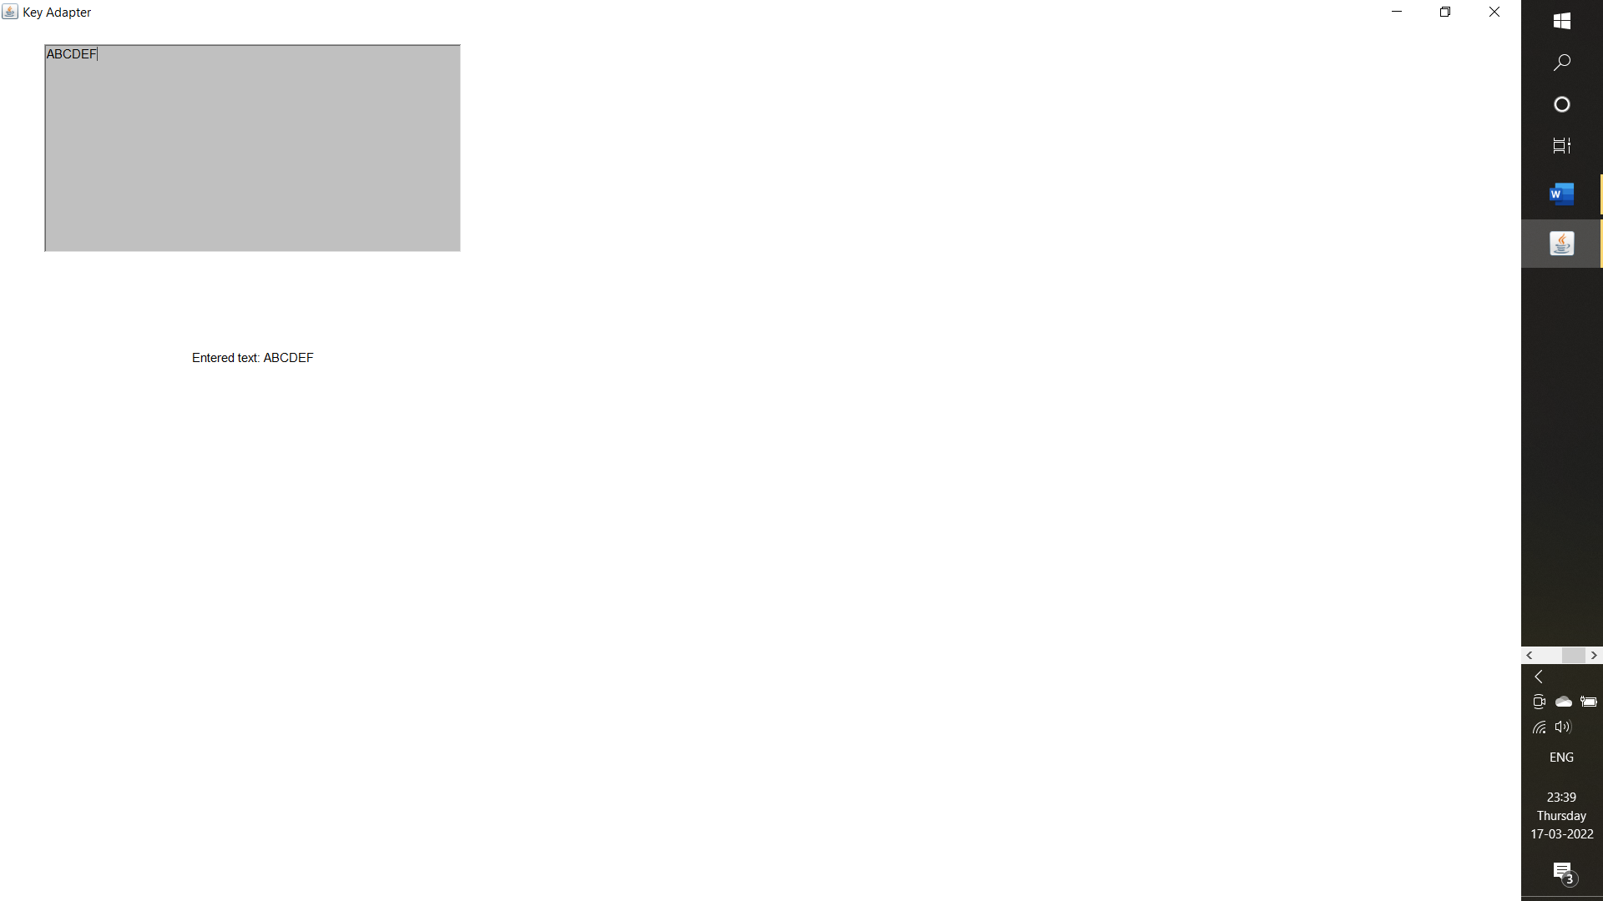

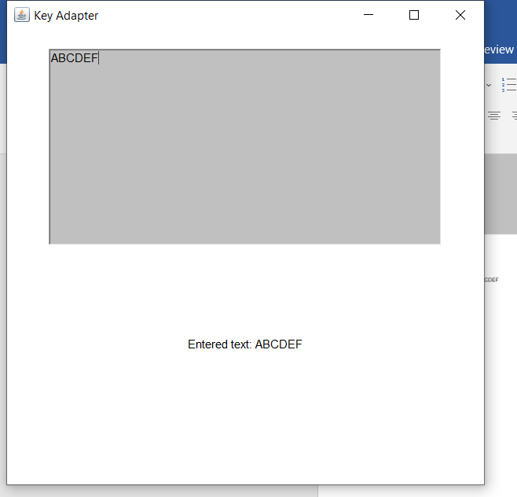

1. The Frame is exited by clicking the cross on top right, or by typing ctrl+c in the console